The Bufallo Field

Hartwin Stüwe-Michel
April 2025
bufallofield@freenet.de

Physikalisches Prinzip
1. Die Umwandlung von Energie in Impuls ohne dass Masse ausgestoßen wird.Der Antrieb durch reine Energie.
Das Bufallofeld ist ein Impulsfeld, in das alle Materie eingebettet ist. Auf die Atomkerne übt das Feld einen Druck in der Größenordnung von ca. 7*10³⁴ Pa aus. Die Annahme einer residualen starken Kernkraft, die den Atomkern entgegen den abstoßenden elektrostatischen Kräften der Protonen zusammenzieht, kann damit fallen gelassen werden. Ändert sich der Impuls des Atomkerns, dann tauscht er Impuls mit dem Feld aus. Dieser Austausch äußert sich als die allgemein bekannte Massenträgheit.
Das Bufallofeld ist ein starkes Impulsfeld, das den gesamten Raum durchdringt. Es besteht aus Bufallos, aus Teilchen, die in alle Richtungen mit Lichtgeschwindigkeit fliegen und eine gewisse Menge an Impuls tragen. Wenn ein Bufallo auf ein schweres Materieteilchen trifft, dann überträgt es einen Teil seines eigenen Impulses auf das Masseteilchen. Beim Verlassen nimmt es den zuvor übertragenen Impuls wieder zurück. Da viele Bufallos auf so ein Masseteilchen treffen und jedes Impuls auf die oben beschriebene Weise mit dem Masseteilchen austauscht, wird auf das Masseteilchen von allen Seiten ein starker Druck ausgeübt.
Das Masseteilchen kann z.B. ein Nukleon sein. Wenn zwei Nukleon sich berühren, dann fehlt an der Fläche wo sie sich berühren der äußere Druck und sie werden wie die Magedeburger Halbkugeln von dem Bufallofeld zusammengepresst. Diesen Effekt kennt man als die starke residuale Kernkraft. Je größer die Fläche mit der sich die Nukleon berühren desto stärker die resultierende pressende Kraft. Sobald sich die Nukleon nicht mehr berühren, ist auch diese Kraft null. Das erklärt, warum die starke residuale Kernkraft in der Reichweite so begrenzt ist.
Inhaltsverzeichnis
Abstract 3
Introduction 3
1. The Bufallo Field 3
1.1 The Bufallo Field Pressure 4
1.2 The Strong Bufallo Force 4
1.3 The Bufallo Gravitation 5
1.4 The Neutron Models 5
1.5 The Strong Reid Force 5
2. The Bufallo Field and the Hard-Sphere Model of the Neutron 6
3. The Bufallo Field and the Soft-Sphere Model of the Neutron 7
4. Conclusion 7
5. Appendix 8
A. Delta Area of a Curved Sphere 8
B. Space-Time Curvature of a Single Mass 10

Abstract
Both the attractive part of the residual strong nuclear force and the gravitational force can be understood as physical effects of a strong momentum field that penetrates the entire space. The so called Bufallo field exchanges momentum with all massive particles.
When it enters the probability cloud of a massive particle it transfers momentum to this and when it leaves it takes this momentum back again. Being penetrated in this way from all sides the massive particle is compressed as if it were exposed to an external pressure.
If the massive particle is exposed to a gravitational field and therefore is in a curved space the massive particle is deformed and its sides are not the same anymore. Especially the side facing the center of curvature is slightly smaller and therefore the pressure accelerates it into this direction. This effect is known as gravitation.
Furthermore if two massive particles touch each other they have a more or less large contact surface. At this contact surface no momentum is exchanged and no pressure acts on this. There is no Bufallo pressure between the touching massive particles and so they are compressed in the same way as the Magdeburg hemispheres.This effect is known as the attractive part of the strong residual nuclear power.
The last effect tells us, that the pressure on a massive particle must be in order of magnitude of the nuclear force. Nevertheless compared with that the first effect is minute because the difference between the sides of the neutron caused by the curvature of space is so tiny.
So it ist possible to calculate the value of the pressure the Bufallo field exerts on a massive particle in curved space to match the well known gravitational force. With this value one can calculate the force pressing two touching massive particles together and compare it with the attractive part of the residual nuclear force. And what can you say – the values differ by only a fracture of an order of magnitude! Bearing in mind that the strong force is about 40 orders of magnitudes stronger than the gravitational the result is astonishing.
The Bufallo Field thus unites the hitherto completely different forces: the attractive part of the strong nuclear force and the gravitional. And you can calculate one from the other.

Introduction
To prove the above concept we calculate the pressure of the Bufallo field from two neutrons in the gravitational. Then the derived strength of pressure is applied to the case of two touching neutrons. The force resulting from the Bufallo field pressure should correspond to the attractive part of the strong nuclear force as derived from the Yukawa potential. This would confirm the Bufallo Field concept.
The first chapter introduces the details of the Bufallo field concept, explaines the models of the neutron used, and discuss the Yukawa potential as a touchstone of the concept.
With the help of the Hard-Sphere model of the neutron the second chapter derives the Strong Bufallo Force and compares it with the attractive part of the strong force, which results from the Yukawa potential.
The third chapter does the same as the second, but with the Soft-Sphere model of the neutron, which leads to even better results.

The Bufallo Field
The Bufallo Field consists of small particles – the bufallos – coming in and out of all directions moving through space like photons in a light field. They transfer momentum to the subatomic particles when they penetrate them. When they leave, they regain momentum from it.
The change of probability density on the path through a particle is proportional to the amount of exchanged momentum.
This momentum transfer results in a constant external pressure on the particles. The bufallos always hit the subatomic particles at the speed of light.

The Bufallo Field Pressure
In the first step, the hard bufallo nucleon models a neutron as a homogeneuos sphere with a radius of about 0,85 fm, where all the momentum exchange with the bufallos takes place on the surface. In the interior of the particle the densitiy of probability is constant and no more exchange of momentum takes place. The reason why this model is presented here is that the strong Bufallo Force between two neutrons can be calculated by hand and one can proof that all the values, physical constants, and calculation steps are correct.
The exchange of momentum at the shell surface results in a radial pressure on the nucleon.
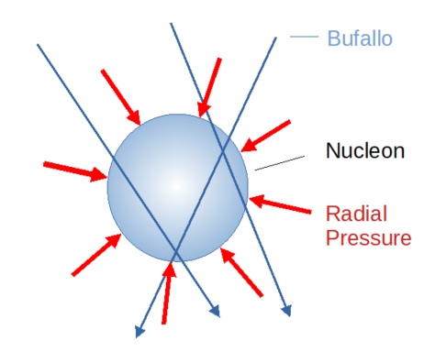

The Strong Bufallo Force
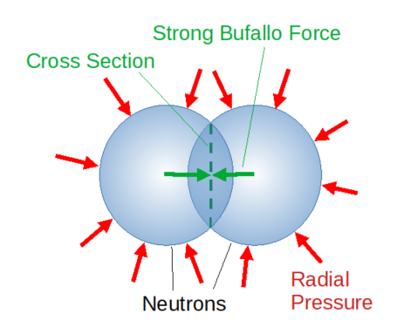
The bufallos exchange momentum when they enter the probability cloud of a particle. All Bufallos traversing both neutrons do not exchange any momentum when they cross the border between them, because they do not experiences any change of density of probability of stay. This results in a total force that presses the neutrons together. Two neutrons can not occupy the same space, therefore it exists an opposing force that increases with decreasing distance between the two neutrons. This force results from the Pauli principle and is loosely refered here as the Fermi force. The Fermi force corresponds to the Strong Bufallo Force on the cross section.
The Strong Bufallo Force is the one that presses two touching neutrons together. For symmetry reasons, only the components of the pressure vectors perpendicular to the cross section do not cancel out and contribute to the Strong Bufallo Force.
If the value of the Bufallo Pressure is known then the product of the cross-sectional area and the Bufallo Pressure gives the value of the Strong Bufallo Force.
The value of the Bufallo Pressure can be calculated frome the well known gravitation and the curvature of space.

The Bufallo Gravitation
As already said at the beginning, according to Einstein’s general theory of relativity, all solid bodies like a neutron in a gravitational field gets spacially curved. Thus the surface of the neutron which points to the center of curvature is smaller than the one which points away from it. Together with the external pressure of the Bufallo field, this gives a resultant force the Bufallo Gravitation which corresponds to the well known force of gravity.
The idea of the Bufallo Field as a gas pressing on the container walls is no longer correct here, since in a conventional gas all spheres at rest remain at rest, even if they are deformed.

The Neutron Models
Neutrons do not have a solid shell or surface in the classical sense. Neutrons are subatomic particles that exhibit both wave and particle characteristics as described by quantum mechanics.
The "diameter" of a neutron, as a theoretical concept, is a measure of the probability of finding the neutron in a given region. This probability distribution can be measured, among other things, by scattering experiments with other particles.
The Hard-Sphere model of a neutron is a homogeneous sphere with a radius of about 0,85fm and a relative density of 1 ( the real value does not matter here).
This model is used in the first step to verify that the strength of the Bufallo Strong Force is in the correct order of magnitude.
The Soft-Sphere model on the other hand uses several overlapping spheres whose radii reproduce a Gaussian distribution function which approximate the probability density distribution of the neutron that is highest in the center and decreases towards the edge. This model is used in the second step and it gives an almost perfect match in the course of the Strong Bufallo Force and the strong nuclear residual force of the Yukawa potential.

The Strong Reid Force
„The strong nuclear force is powerfully attractive between nucleons at distances of about 0.8 femtometre (fm, or 0.8×10−15 metre), but it rapidly decreases to insignificance at distances beyond about 2.5 fm“
The Reid potential V_{reid} in MeV describes the nuclear force phenomenologically.

With
r : distance to center of mass between two nucleii
m : 0.7 fm⁻¹
V_{reid}: Residual nuclear potential in [MeV]
(see: https://en.wikipedia.org/wiki/Nuclear_force)
The Strong Reid force F_{reid} is the negative derivative of theV_{reid} potential:

With
r : distance to center of mass between two nucleii
m : 0.7 fm⁻¹
F_{reid}: Residual nuclear force in [MeV/m] = = 1,60217733000001E-13 Newtonmeter [N·m]

The Bufallo Field and the Hard-Sphere Model of the Neutron
The Hard Sphere Model approximates a nucleon by a single homogenous sphere
This is a beautiful result but looks a bit ugly. Beautiful, because it shows that the two forces are in the same order of magnitude, and ugly because their course clearly deviates from each other. But we can do better as we will see with the Soft-Sphere Model of the neutron.
How big is the pressure on the bufallo nucleon?
It can be calculated when the nucleon is in a gravitational field.
The space is curved, as is the sphere of the nucleon.
This means the part of the surface of the sphere pointing to the center of curvature is smaller than the part pointing away from it.
Therefore the force pushing the nucleon away from the center is smaller than the force pushing it towards the center.
The difference between the two forces must equal the gravity force.
So the difference of the two surface areas the delta area ¢_{s} caused by the curvature is required to calculate the bufallo pressure P_{bufallo}.
According to equation A1 (see Appendix A) the delta area ¢_{s} of a sphere is
¢_{s} = f_{curv}
with equation B3 ( see Appendix B)
f_{curv} = =
r : Radius of the sphere
r_{curv}: Radius of curvature
D: Distance from curvature center
c: Velocity of light.
G: Gravity constant
m_{nucl}: Mass of nucleus causing the curvature of space
To calculate the strength of the bufallo pressure P_{bufallo} consider two nucleons with mass m_{nucl} and radius r_{nucl} at a distance D far greater than their radius r_{N}
The gravitational Force F_{grav} between them according to Newton is
F_{grav} =
The Bufallo force is the product of pressure and the delta area.
F_{bufallo} = P_{bufallo} ¢_{s} = P_{bufallo}
F_{grav} shall equal F_{bufallo}:

This leads to
= P_{bufallo}
The distance D, the gravitational constant G and one mass of nucleon m_{nucl} cancel out and the result is:
P_{bufallo} = = 5,8518 * 10³⁴ N / m² c
with
G: Gravitational constant
m_{nucl}: Mass of a neutron = 1.67492749804*10⁻²⁷ kg
r : Radius of a neutron = 1.7*10⁻¹⁵ / 2 m
c : Velocity of light = 299792458 m / secs

The Bufallo Field and the Soft-Sphere Model of the Neutron

Conclusion
The Strong Bufallo Force equals the attractive part of the strong nuclear force of the Reid potential almost perfectly. It was not to be expected that the derivation of the strongest force in universe from the weakest one would lead to such a result. Because the difference between these two are in the range of 40 orders in magnitude.
The sphere of space curvature with a radius of ???? used here does by far not fit in the visible universe with an extension of 14 billion light years = 14 * 10⁹ * 9,460 *10¹²=° 132,449 * 10²¹ m

Appendix

A. Delta Area of a Curved Sphere
Sphere
Radius : r
Volume : V_{s} =
Cross area : A_{s} =
Delta area : ¢_{s} = ?
Approximate sphere volume by rods pointing into the direction of curvature centre.
Rod:
Number of Rods : n
Index of rod : i
Length : L_{i}
Cross area : Δs = A_{s} / n
Rod volume : V_{r} = L_{i} Δs

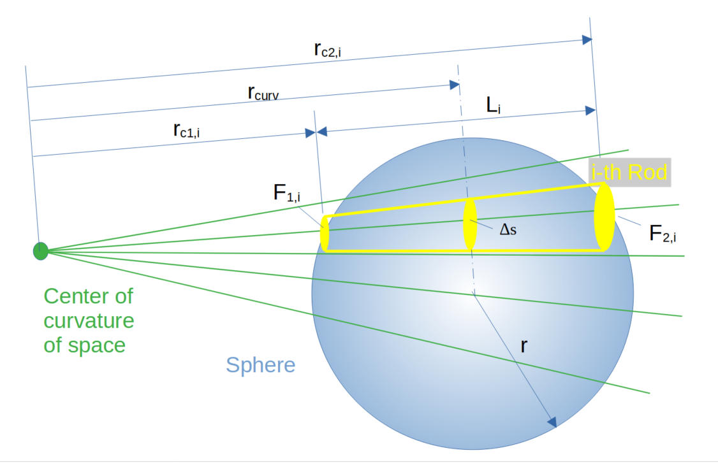
The face F₁ of the rod pointing into the direction of curvature center is smaller than F₂. because of the curvature of space:
Curvature
Radius : r_{curv}
Factor : f_{curv} =
Area of face F1 : A_{F1}
Area of face F2 : A_{F2}
Face-Area-Delta : ε_{i}
ε_{i} =
=
=
=
with

follows
ε_{i} = L_{i} Δs / r_{curv}
= f_{curv} L_{i} Δs

Curvature of sphere ¢_{s} is the sum of all Face-Area-Deltas:
¢_{s} =
=
= f_{curv}
The volume of all rods equals the volume of the sphere, therefore
¢_{s} = f_{curv} V_{s}

(A1)
The face area delta of the sphere ¢_{s} equals the product of curvature factor and sphere volume.

B. Space-Time Curvature of a Single Mass
To calculate the space time curvature of a mass M one calculate three points of the trajectory of a test particle P in some distance from M.

From three points A, B, C in Minkowski space the radius of curvature can be calculated by the following formula:

because we expect h to be very small in comparision with s one can write

( B1)

Now we calculate the trajectory of a free falling test particle P in the gravitational field of mass M
At time t_{o} the particle P has velocity v_{x} = v_{y} = v₀ much smaller than the speed of light c.
P experiences a gravitational acceleration a
(B2)
with
G: gravitational constant
The coordinates of the three points can be calculated as follows

for symmetry reasons

integrating y yields:

with y_{a} = 0 follows

The three points in Minkowski space are

To apply the formula B1 we calculate h and s as:

with v_{a} << c

The curvature radius

The curvature f_{curv} with equation B2 is
(B3)

